**VISHNU INSTITUTE OF TECHNOLOGY(A)**

**DEPARTMENT OF MECHANICAL ENGINEERING**

**SOFTWARE ENGINEERING**

**II B.Tech II SEM MID-I**

**Question Bank**

**UNIT-I**

**Each question carries 10 marks.**

1. What is software engineering. How has software engineering evolved? [CO1][L1]
2. How does the interpretation of perceived problem complexity, based on human cognition mechanisms, impact the process of exploratory data analysis? [CO1][L2]
3. For which types of development projects is the V-model appropriate. Briefly explain the V-model and point out its strengths and weaknesses. [CO1] [L2]
4. Distinguish between software products and services. Give examples of each. [CO1] [L2]
5. With respect to the rapid application development (RAD) model, answer the following: [CO1] [L3]

(a) Explain the different life cycle activities that are carried out in the RAD model.

(b) How does RAD help in faster software development.

(c) Give examples of two projects for which RAD would be a suitable model for development.

(d) Identify the characteristics that make a project suited to RAD style of development.

(e) Identify the characteristics that make a project unsuited to RAD style of development.

6. Explain the important features of the agile software development model. [CO1] [L3]

(a) Compare the advantages and disadvantages of the agile model with iterative waterfall and the exploratory programming model.[5M]

(b) Is the agile life cycle model suitable for development of embeddedsoftware? Briefly justify your answer. [5M]

7.Compare the relative advantages of RAD, iterative waterfall, and the evolutionary models of software development. [CO1] [L2]

8. Explain the emergence of software engineering principles.

[CO1][L1]

9. Explain the different phases of the Waterfall Model.[CO1] [L1]

10.Explain the characteristics of a control flow diagram and draw a control flow diagram for the given code. [CO1][L4]

#include <stdio.h>

int main() {

int n1, n2, i, gcd, lcm;

printf("Enter two positive integers: ");

scanf("%d %d", &n1, &n2);

// loop to find the GCD

for (i = 1; i <= n1 && i <= n2; ++i) {

if (n1 % i == 0 && n2 % i == 0)

gcd = i;

}

lcm = (n1 * n2) / gcd;

printf("The LCM of two numbers %d and %d is %d.", n1, n2, lcm);

return 0;

}

**UNIT-II**

**Each question carries 10 marks**.

1. At which point in the software development life cycle (SDLC), does the project management activities start? When do these end? Identify the important project management activities.

[CO2][L2]

2. What are the different categories of software development projects according to the COCOMO estimation model? Give an example of software product development projects belonging to each of these categories. [CO2] [L3]

3. Briefly explain the about the Basic COCOMO estimation model and the COCOMO 2 estimation model. [CO2][L1]

4. What does Halstead’s volume metric represent conceptually? How according to Halstead is the effort dependent on program volume? [CO2] [L2]

5. Suppose you are the project manager of a software project requiring the following activities. [CO2] [L4]

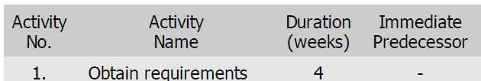 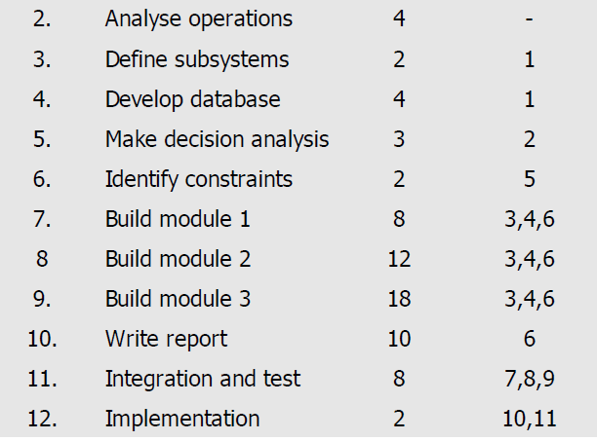

1. a) List the important shortcomings of LOC for use as a software size metric for carrying out project estimations. [5M][CO2] [L2]

b) Explain the metrics used for calculating Lines of Code (LOC).[5M]

7. a)Explain why the development time of a software product of

given size remains almost the same, regardless of whether it is organic, semidetached, or embedded type. [CO2] [L1][5M]

b)Explain the Halstead’s method-Analytical technique for

calculating estimated length, volume and level of abstraction. [5M]

8. Consider a software project with 5 tasks T1-T5. Duration of the 5 tasks (in days) are 15, 10, 12, 25 and 10, respectively. T2 and T4 can start when T1 is complete. T3 can start when T2 is complete. T5 can start when both T3 and T4 are complete. When is the latest start date of the task T3? What is the slack time of the task T4?

[CO2] [L4]

9. In the context of software configuration management, answer the following: [CO2] [L2]

(a) What do you understand by software configuration? [2M]

(b) What is meant by software configuration management?[2M]

(c) How can you manage software configuration (only mention the names of the principal activities involved)?[2M]

(d) Why is software configuration management crucial to the success of large software product development projects (write only the importantreasons)?[2M]

(e) What is change control board (CCB) and what is its role in software configuration management?[2M]

10. List three common types of risks that a typical software project might suffer from. Explain how you can identify the risks that your project is susceptible to. Suppose you are the project manager of a large software development project, point out the main steps you would follow to manage risks in your software project. [CO2][L2]